**DIGITAL IMAGE ANALYSIS**

**(CSL-461)**

**REPORT for**

**ASSIGNMENT-1**

Submitted by:

Parul (2016CSB1048)

Table of Contents

1 NEGATIVE: 2

2 LOG TRANSFORMATION: 3

3 GAMMA TRANSFORMATION: 4

4 BIT PLANE SLICING: 5

5 GRAY LEVEL SLICING: 8

6 CONTRAST STRETCHING: 9

7 ROTATION: 10

8 TRANSLATION: 11

9 RESIZING/SCALING: 12

10 SHEARING: 13

11 HISTOGRAM EQUALISATION: 14

12 HISTOGRAM MATCHING: 15

13 ADAPTIVE HISTOGRAM EQUALISATION: 17

14 IMAGE RECONSTRUCTION USING TIE POINTS: 18

# NEGATIVE:



Figure 1: Original Image

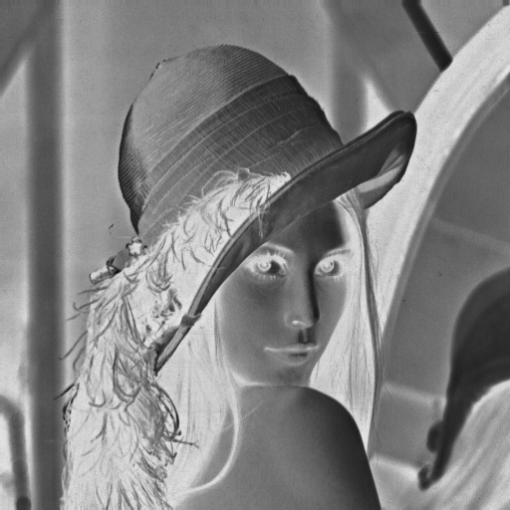

Figure 2: Transformed Image

# LOG TRANSFORMATION:

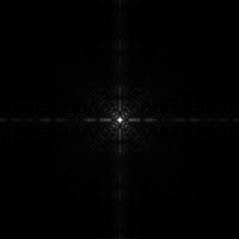

Figure 3: Original Image

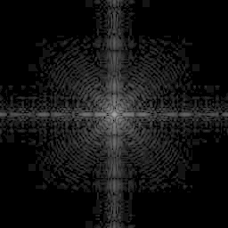

Figure 4: Transformed image(s=30*log (1+r))

# GAMMA TRANSFORMATION:

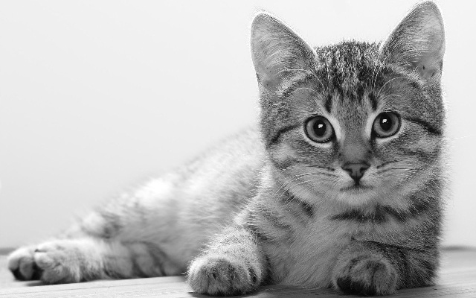

Figure 5: Original Image

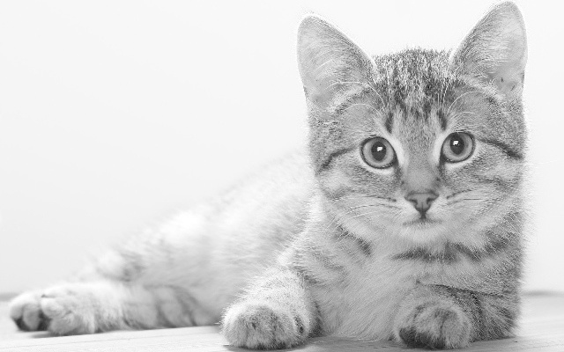

Figure 6: Transformed Image (gamma=0.5)

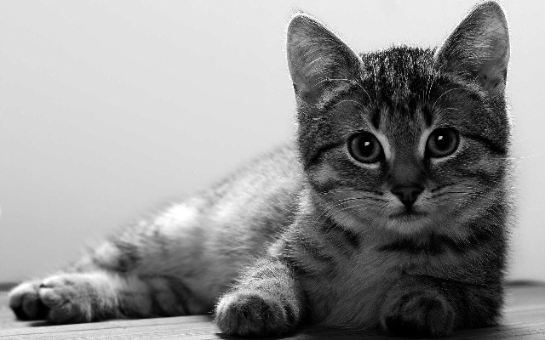

Figure 7: Transformed Image (gamma=2)

# BIT PLANE SLICING:

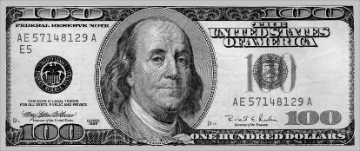

Figure 8: Original Image

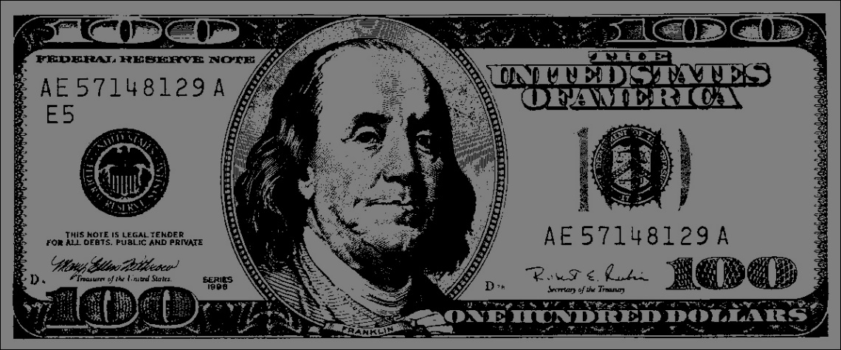

Figure 9: Transformed Image (bit plane 8)

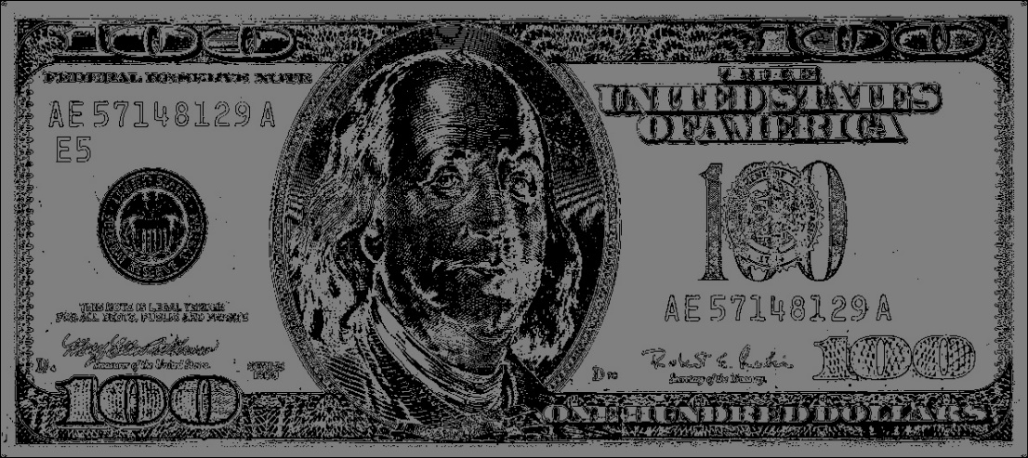

Figure 10: Transformed Image (bit plane 7)

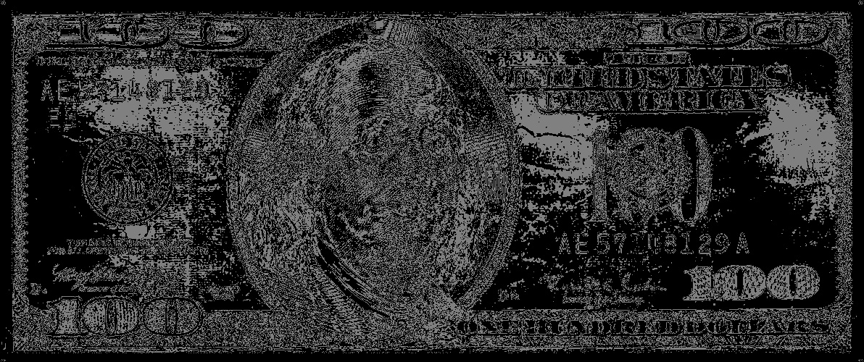

Figure 11: Transformed Image (bit plane 6)

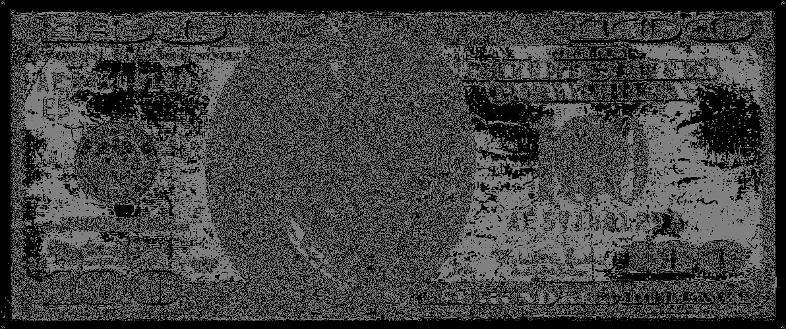

Figure 12: Transformed Image (bit plane 5)

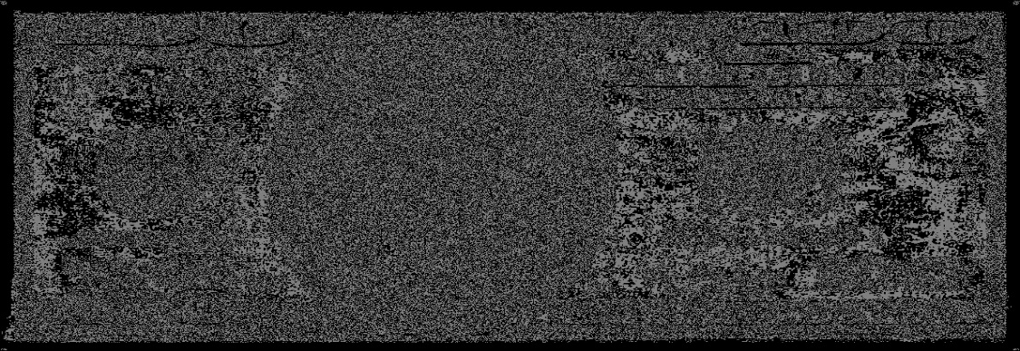

Figure 13: Transformed Image (bit plane 4)

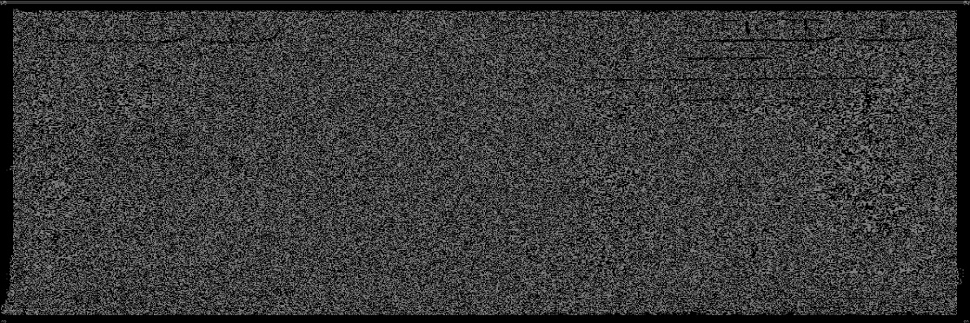

Figure 14: Transformed Image (bit plane 3)

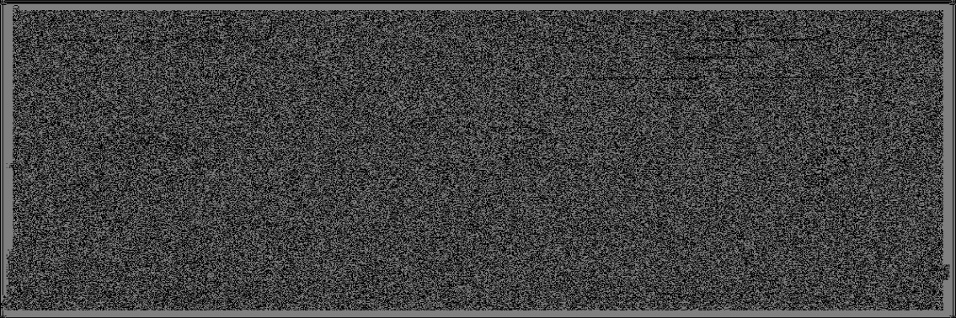

Figure 15: Transformed Image (bit plane 2)

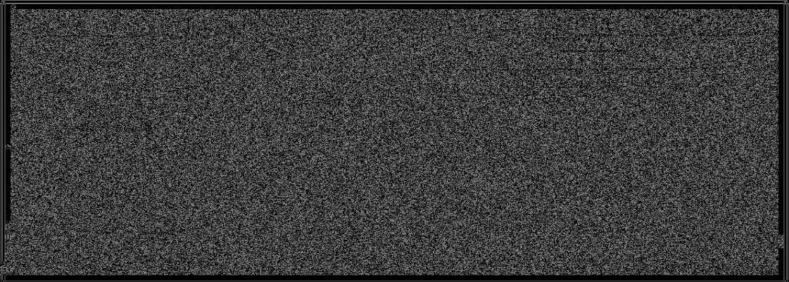

Figure 16: Transformed Image (bit plane 1)

# GRAY LEVEL SLICING:



Figure 17: Original Image

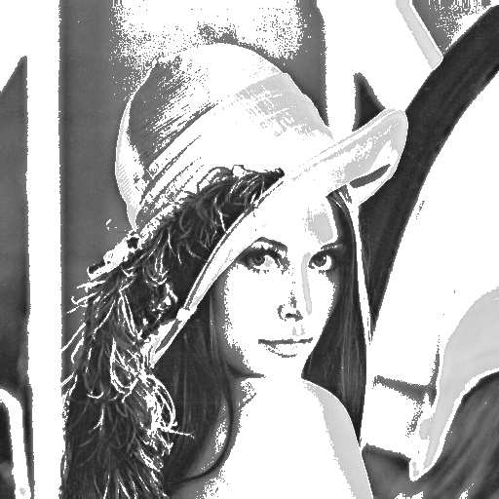

Figure 18: Transformed image (Gray levels 125 to 200)

# CONTRAST STRETCHING:

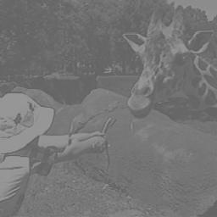

Figure 19: Original Image

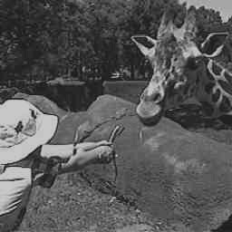

Figure 20: Transformed Image (r1=100, s1=30, r2=150, s2=200)

# ROTATION:



Figure 21: Original Image



Figure 22: Rotated Image (45 degrees) - Nearest neighborhood Interpolation



Figure 23: Rotated Image (45 degrees) - Bilinear Interpolation

# TRANSLATION:



Figure 24: Translated Image

# RESIZING/SCALING:



Figure 25: Original Image [512X512 pixels]



Figure 26: Resized Image (Horizontal: 2, Vertical: 0.25, Bilinear Interpolation) [1024X128 pixels]

(PSNR = 46.5902 dB)



Figure 27: Resized Image (Horizontal: 2, Vertical: 0.25, Nearest Neighborhood Interpolation) [1024X128 pixels] (PSNR = 39.4299 dB)

# SHEARING:

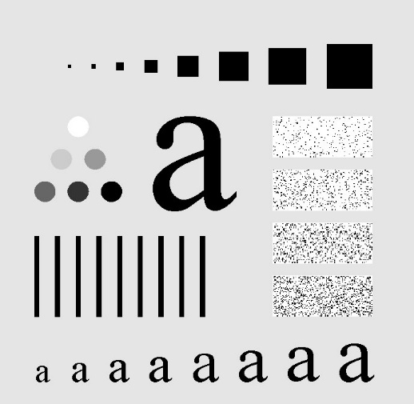

Figure 28: Original Image

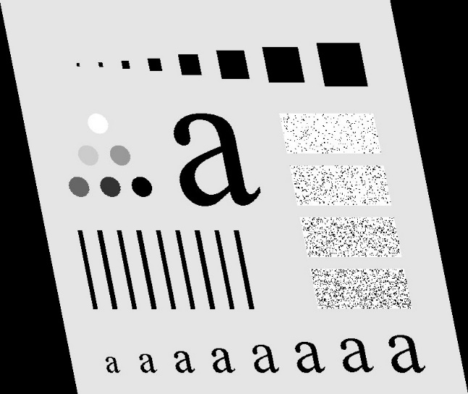

Figure 29: Horizontally Sheared (Bilinear Interpolation)

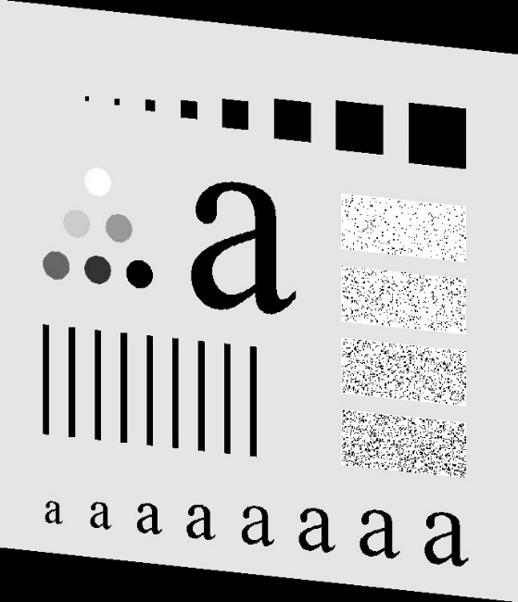

Figure 30: Vertically Sheared (Bilinear Interpolation)

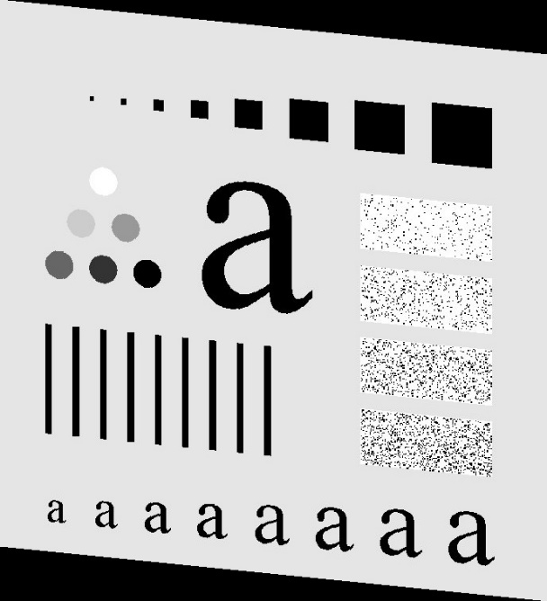

Figure 31: Vertically Sheared (Nearest Neighborhood Interpolation)

# HISTOGRAM EQUALISATION:

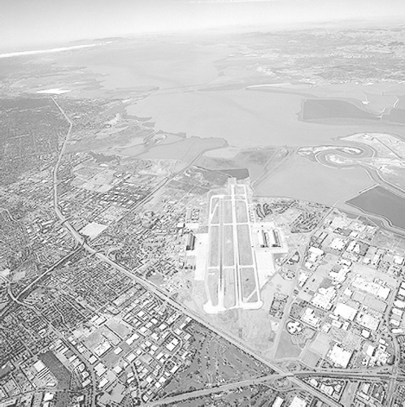

Figure 32: Original Image

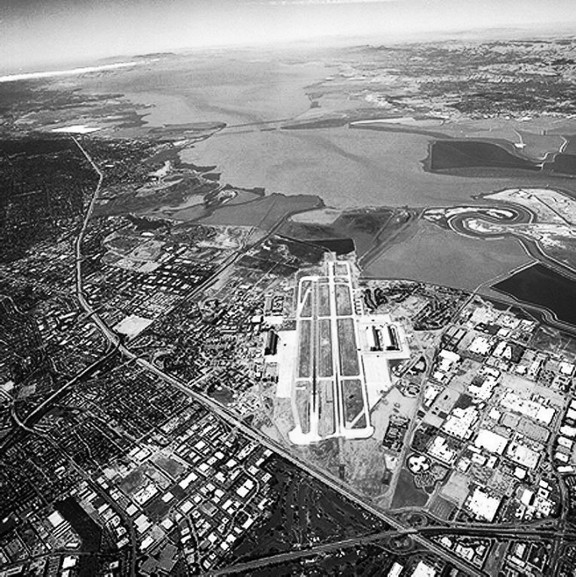

Figure 33: Transformed image (PSNR = 50.8795 dB)

# HISTOGRAM MATCHING:

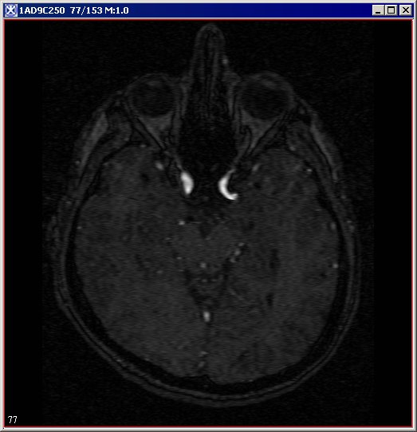

Figure 34: Original Image-1

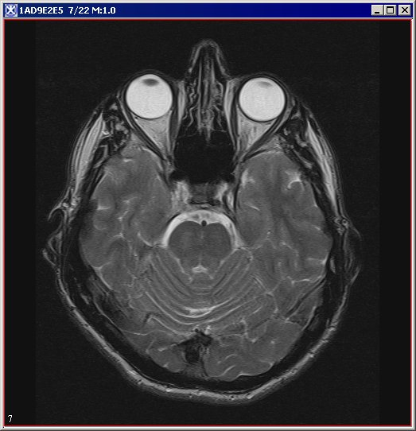

Figure 35: Original Image-2

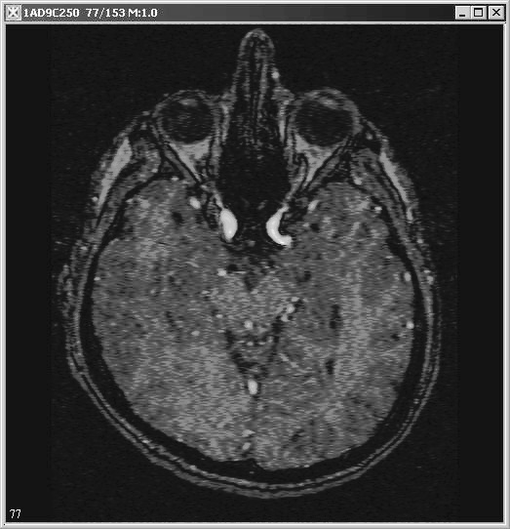

Figure 36: Image formed by Histogram Matching

# ADAPTIVE HISTOGRAM EQUALISATION:

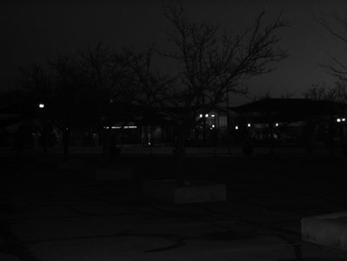

Figure 37: Original Image

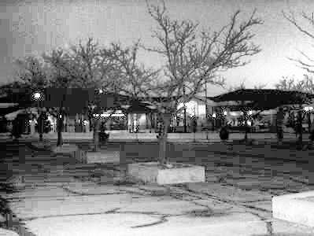

Figure 38: Transformed Image

# IMAGE RECONSTRUCTION USING TIE POINTS:

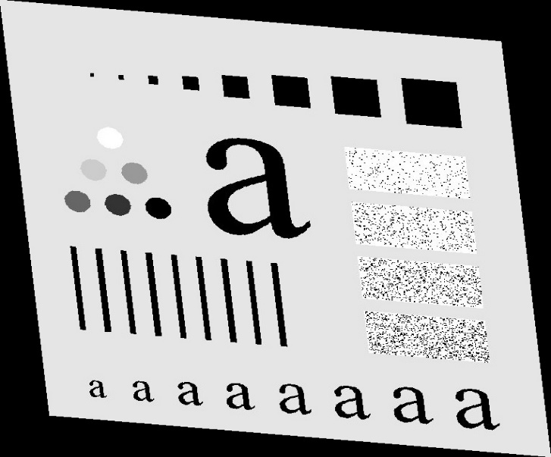

Figure 39: Original Sheared Image

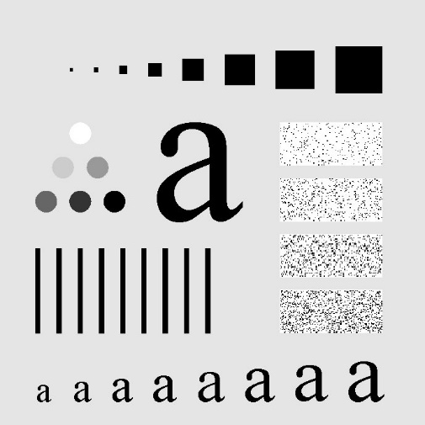

Figure 40: Desired un-sheared image

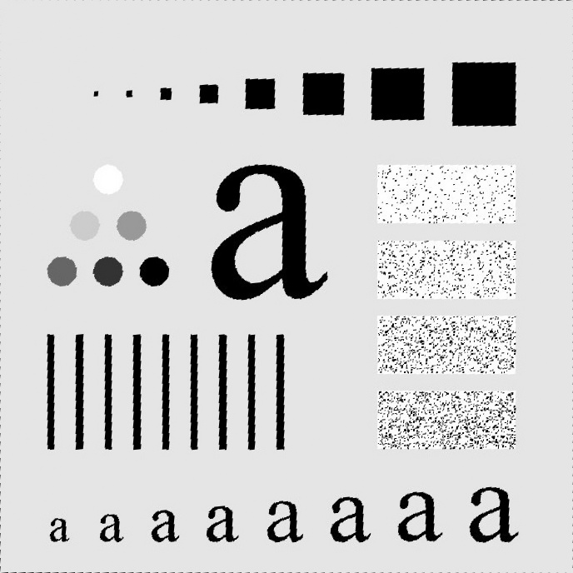

Figure 41: Transformed Image

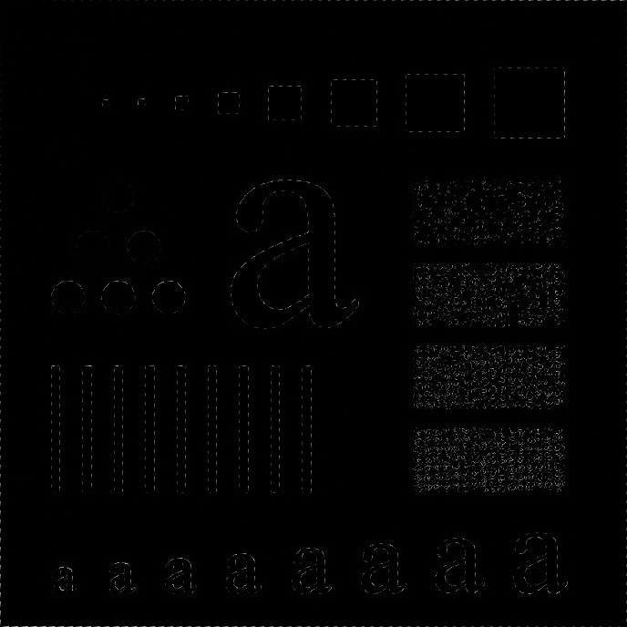

Figure 42: Difference of un-sheared original image and the image constructed using tie points